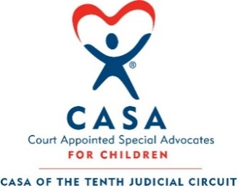
Par 3 Challenge &
$1 Million Hole-in-One Shootout
September 29th, 2026 Country Club of Peoria


Exclusive Presenting Sponsor

Sponsorship Opportunities and Benefits

 |  |  | 4 Sold Already! | Prairie Home Alliance | 1 Sold  Already! | Par-A-Dice
Levels of Support | Hole  Sponsor | Cart  Sponsor | Mission  Sponsor | Hospitality  Sponsor SOLD | Deluxe  Sponsor | Putting Contest Sponsor  SOLD
Sponsorship Levels | $100 | $1,000 | $2,000 | $5,000 | $2,500 | $5,000
Golfers ($300 value per golfer) |  |  | 4 golfers | 8 golfers | 4 golfers | 8 golfers
Mention in any broadcast media coverage CASA can garner related to the event (radio/print/TV) |  |  |  |  | □ | □
Area for your business to promote your services |  | Cart Sign | Mission Handout | □ | □ | □
Company name/logo placement in one issue of CASA Newsletter: Voice, following the event |  | □ | □ | □ | □ | □
May supply promotional material/literature to be distributed to all golfers | □ | □ | □ | □ | □ | □

Sponsorships Putting Contest Sponsor: $5,000 = __$________________
Deluxe Sponsor: $2,500 = __$________________
Hospitality Sponsor: $5,000 = __$____SOLD_______
Mission Sponsor: $2,000 = __$________________
Cart Sponsor: $1,000 = __$________________
Hole Sponsor: _____ # of hole signs X $125
= __$_________________

Golf Registration (list golfers and/or guests on the reverse side)
_____ # of Foursome Groups X $1,200/Group = __$_________________
_____ # of Individual Golfers X $300/Person = __$_________________

TOTAL AMOUNT DUE = __$__________________
Payment Information

Check enclosed (made payable to CASA of the Tenth Judicial Circuit)
Send me an invoice
For credit card payments, please contact Kim Leman, CASA Fiscal Event Officer, at 309-981-5162.

Name
Company
Street Address
City, State, Zip
Email |  | Phone #

Return this completed form to: CASA of the Tenth Judicial Circuit, 324 Main Street, Room 215, Peoria IL 61602 or casa@peoriacounty.org. For additional information, please contact CASA at (309) 669-2939 or casa@peoriacounty.org.

Par 3 Challenge &
$1 Million Hole-in-One Shootout

September 30th, 2025 □ Country Club of Peoria

Attendee Information

Foursome Group 1 Information:
Name | Address | City, State & Zip | Email | Phone

Foursome Group 2 Information:
Name | Address | City, State & Zip | Email | Phone

Individual Golfer Information:
Name | Address | City, State & Zip | Email | Phone

