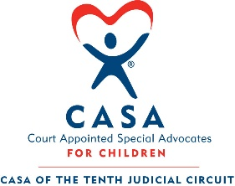
CASA of the Tenth Judicial Circuit

July 30, 2026

RE: Par 3 Challenge & $1 Million Hole-In-One Shootout
Presented by Connor Co.
Tuesday, September 29th, 2026
Country Club of Peoria

Dear CASA Friend,

Everyone at CASA of the Tenth Judicial Circuit is excited about the 16th Annual Par 3 Challenge & $1 Million Hole-In-One Shootout on Tuesday, September 29th at the Country Club of Peoria.

We invite you to participate by being a sponsor, a golfer, or both! Join us for a unique afternoon of golf, and if your team is one of the top 10 in the scramble, one golfer from your team will participate in the Shootout for a chance to win $1 Million!

Please review the enclosed materials for sponsorship opportunities and golf registration.

CASA of the Tenth Judicial Circuit works to ensure that every child who has experienced abused and neglected is placed in a safe and permanent home. Our Advocate Supervisors utilize specially trained community volunteers who advocate for these children as they go through the Juvenile Abuse and Neglect Court system. Please consider supporting this event and CASA’s important mission.

Thank you so much for your time and consideration.

With appreciation,

Jeff Doeden, LPL Financial Advisor & Doed Knows Taxes
Par 3 Challenge Chairperson

Executive Director
Pamela Perrilles
Board of Directors
Kari Burg-Braggs, President
Matt Campen, VP
Mark Mason, Treasurer
Steve Howard, Asst Treasurer
Mandy Watson, Secretary
At Large Members
James Kemper
Andrew Barra
Mark Plunkett
Valerie Moehle
Bob McCullum
Love Ugorji
Peggy Crane
Kim Geno
Keila Sierra Cintron
Frank Ierulli
Kevin Sletten
Jen Croland
Program Director
Lisa Norwood
Fiscal Event Officer
Kim Leman

